Web Application Security Testing Report - Task 1
1. Introduction and Objectives
Project Aim: This report documents a comprehensive security assessment of the Damn Vulnerable Web Application (DVWA), conducted within a controlled laboratory environment. The primary objective was to methodically identify, exploit, and analyze a range of critical security weaknesses. The investigation focused on three prevalent attack vectors: SQL Injection (SQLi), Cross-Site Scripting (XSS), and authentication attacks via Brute Force methods. The analysis serves to illustrate the tangible risks posed by these flaws and to propose robust mitigation measures for strengthening web application defenses.

2. Exploitation of SQL Injection (SQLi) Vulnerabilities
This section details the process of leveraging an SQL Injection flaw within the DVWA platform.
Test Environment:
- Application: Damn Vulnerable Web Application (DVWA)
- Database: MySQL
- Target Module: SQL Injection
- Configuration: Low Security Setting
Core Objectives: The goal of this exercise was to successfully execute SQL Injection attacks to achieve the following:
- Extract user records from the database.
- List all tables within the application's database schema.
- Map the column structure of specific tables.
Attack Execution and Findings:
- Initial Vulnerability Confirmation:
  - A simple input of - 1 was submitted to the User ID field.
  - Outcome: The application returned the record for user ID 1, displaying the first name and surname as "admin".
  - Analysis: This behavior confirmed that the backend was executing a raw SQL query like SELECT FROM users WHERE id = '1' without sanitizing the input.
- Authentication Bypass:
  - Payload: An input of 1' or '1'='1 was used to manipulate the query logic.
  - Outcome: The attack successfully bypassed the intended logic, causing the database to dump all user records, including Admin, Gordon Brown, and others.
  - Impact: This demonstrates a critical authentication bypass and complete enumeration of the user table.
- Database Schema Enumeration (Table Names):
  - Payload: -1' UNION SELECT table_name, NULL FROM information_schema.tables WHERE table_schema = 'dvwa' -- was injected.
  - Outcome: The query returned the names of tables within the database, specifically guestbook and users.
  - Impact: This provided the attacker with knowledge of the database structure, identifying high-value targets like the users table.
- Table Structure Enumeration (Column Names):
  - Payload: -1' UNION SELECT column_name, NULL FROM information_schema.columns WHERE table_name = 'users' -- was used to investigate the users table.
  - Outcome: The attack revealed the column names within the users table, such as user_id, first_name, and last_name.
  - Impact: This allowed for a full mapping of the user table's structure, exposing the exact fields containing sensitive data.
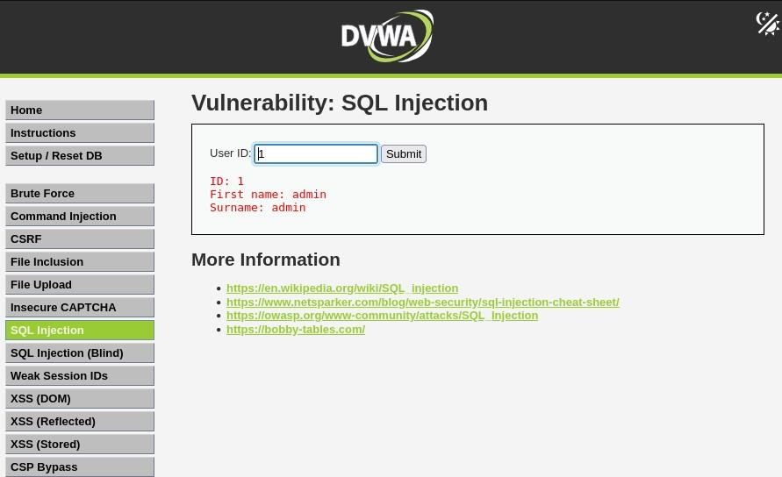
SQLi Conclusion: The successful execution of these attacks demonstrates that the application's failure to implement proper input validation and parameterized queries created a critical SQL injection flaw. This vulnerability allowed for the complete exfiltration of confidential user data and exposure of the database's internal architecture.
SCREEENSHOTS :-

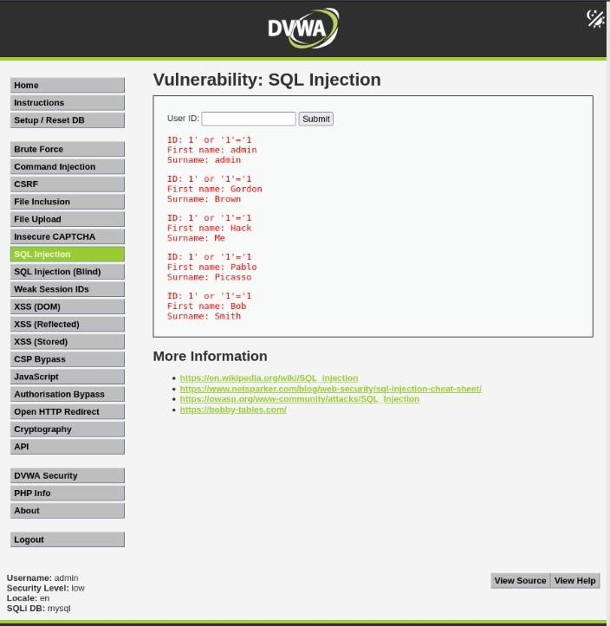

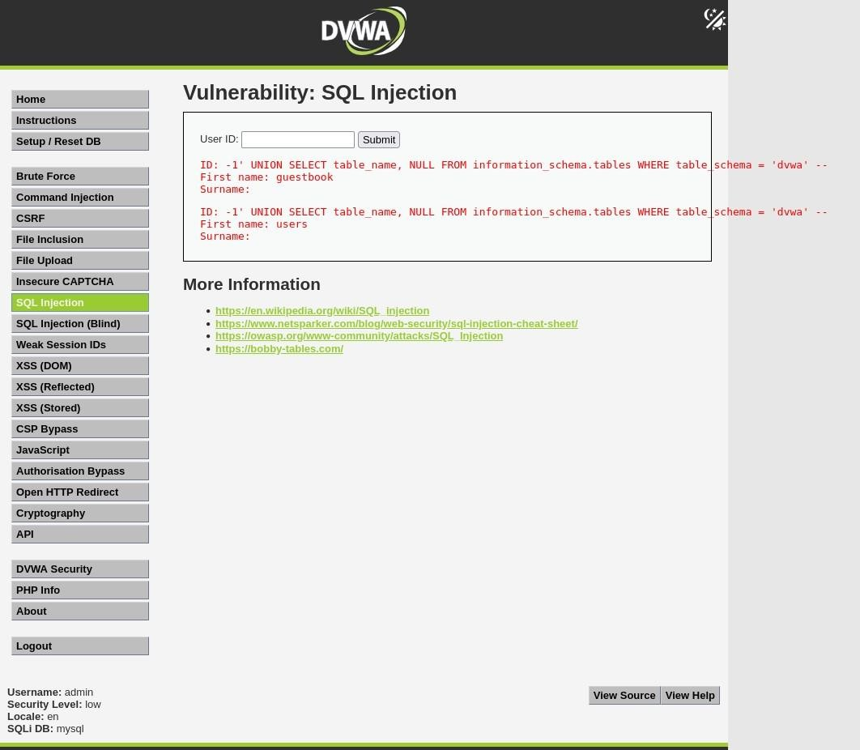

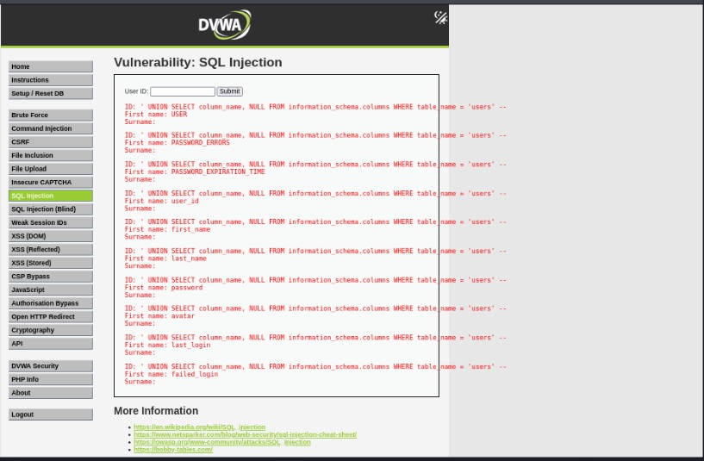

3. Analysis of Cross-Site Scripting (XSS) Vulnerabilities
This part of the assessment covers the identification and exploitation of three distinct XSS variants within DVWA.
3.1. Reflected XSS
- Description: This vulnerability arises when an application reflects user-provided data back to the browser without proper sanitization.
- Execution: The "XSS (Reflected)" module was targeted. A payload of
<script>alert('XSS')</script> was submitted into an input field.
- Result: The script was immediately executed by the browser upon response, triggering an alert box.
3.2. Stored XSS
- Description: This more persistent flaw involves a malicious script being saved to the server (e.g., in a comment field) and executed in the browser of any user who views the stored content.
- Execution: In the "XSS (Stored)" module, a guestbook entry was submitted with the name "test user" and the message payload <script>alert('Stored XSS')</script>.
- Result: The script was stored, and an alert box appeared each time the guestbook page was loaded, confirming the persistent nature of the attack.
XSS Variant | Stored on Server | Trigger | Risk Level | Common Location
Reflected XSS | No | Immediate page response | Medium | Search fields, forms
Stored XSS | Yes | Viewing stored data | High | Comment sections, messages
XSS Conclusion: The successful exploitation of all XSS types underscores how a lack of sufficient input validation and output encoding can lead to severe client-side security breaches.

SCREEENSHOTS :-

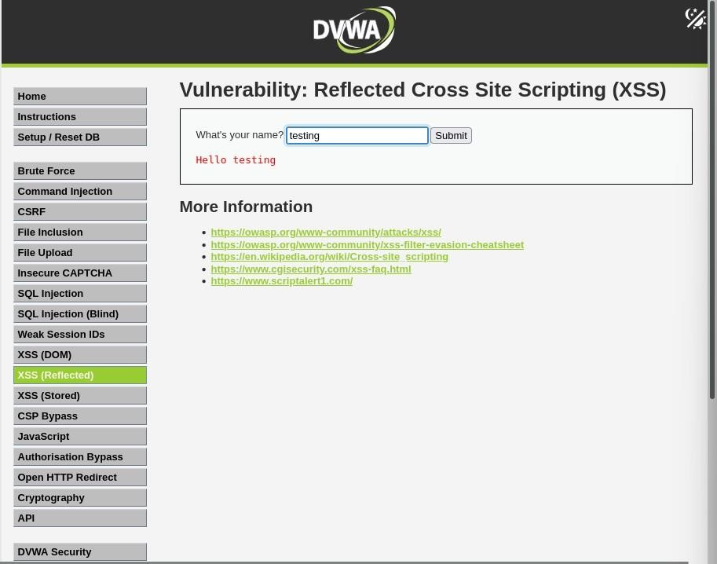
Reflected XSS:

Stored XSS
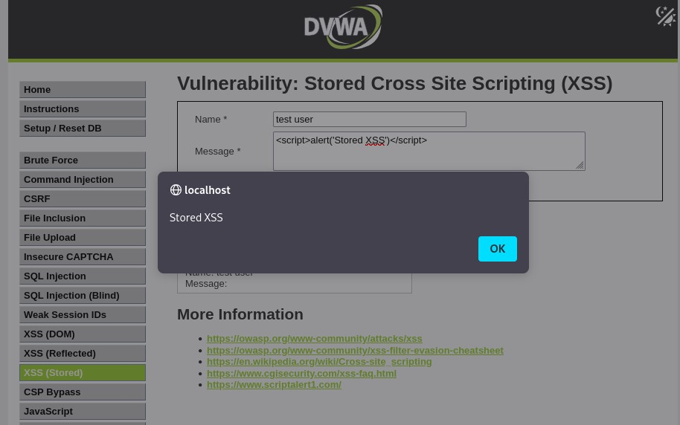

4. Simulation of a Brute Force Authentication Attack
This section outlines a simulated brute force attack against a login mechanism using professional security tools.
Objective: The goal was to demonstrate how weak login controls can be compromised by systematically guessing passwords using Burp Suite's Intruder tool.
Environment and Tools:
- Platform: Kali Linux
- Application: DVWA
- Tool: Burp Suite
- Payload: A custom password dictionary
Attack Procedure:
- Request Interception: A login attempt was made on the "Brute Force" module to capture the POST request containing the authentication credentials.
- Intruder Configuration: The captured request was sent to the Burp Suite Intruder tool. A payload position was defined for the password parameter, and Intruder was loaded with a custom password wordlist.
- Attack Execution: The attack was launched, with Intruder systematically sending a new request for each password in the wordlist. The status codes and response lengths of each attempt were closely monitored.
- Result Analysis: A successful login was identified by observing a unique response length and status code that differed from the failed attempts. The correct password was determined to be password.
Brute Force Conclusion: The application was found to be vulnerable to a brute-force attack due to the complete absence of protective measures like rate limiting or CAPTCHA, even on its highest security setting. This highlights a critical oversight in the authentication design.
Security Recommendations:
- Implement a strict account lockout policy after a set number of failed login attempts.
- Integrate CAPTCHA or similar mechanisms to prevent automated attacks.
- Enforce strong password policies and deploy Multi-Factor Authentication (MFA).
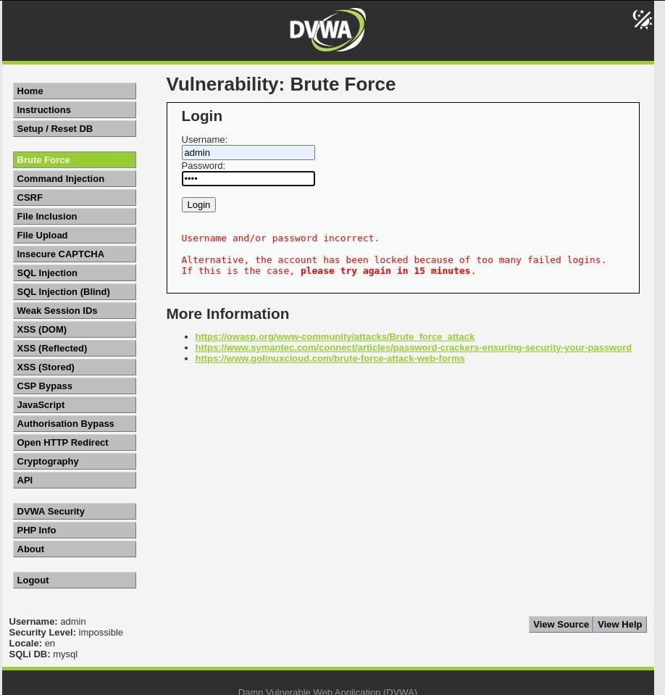
SCREEENSHOTS :-
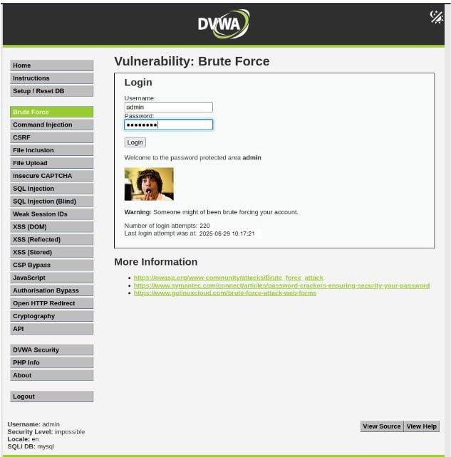

5. Overall Assessment Summary
This security assessment of DVWA confirmed that common vulnerabilities such as SQL Injection, Cross-Site Scripting, and weak authentication controls can be readily exploited to compromise a web application. Each attack scenario revealed significant security gaps that, in a live environment, could lead to severe consequences like data breaches, unauthorized system access, and financial loss.
This investigation underscores the critical importance of a defense-in-depth security posture, which must include:
- Rigorous input validation and output encoding on all user-supplied data.
- Adherence to secure coding practices, such as the use of parameterized statements (prepared statements) to prevent SQLi.
- Robust authentication systems that include rate limiting, CAPTCHA, and MFA.
- Regular security audits and penetration testing to proactively identify and remediate weaknesses.

